

**CSP2108 Introduction to Mobile Applications Development**

[**Assignment #2**](https://blackboard.ecu.edu.au/webapps/assignment/uploadAssignment?content_id=_5868253_1&course_id=_649759_1&group_id=&mode=view)

**Project 1: Caravan GPS App (Aussie Go-Road)**

**Ashley Thorne-Jeffrey 10284803**

**Lynette Lowe 10402581**

**Michael Ibesa 10424204**

**Ricardo Felix Costa 10428094**

Table of Contents

Group Meetings 3

Meeting 1 3

Meeting 2 4

Meeting 3 5

Meeting 4 6

Client Communication 7

Client Communication 1 7

Client Communication 2 11

Evidence of Appropriate Configuration Management 15

Evidence of Pair-Programming 16

Photographic Evidence 16

Textual Evidence 17

Scope Change 18

Proposed Scope Change 18

Change Request & Approval 19

Updated List of Functional & Non-Functional Requirements 20

Black Box Testing 21

Client Acceptance 28

Readme 29

Group Self-Reflection 30

References 31

# Group Meetings

## Meeting 1

**Meeting No:** 1

**Date:**  08 October 2018

**Time:** 12:00pm-14:00pm

**Venue:** Building 18, Room 204

**Participants:** Ashley Thorne-Jeffrey, Lynette Lowe,Michael Ibesa, Ricardo Felix Costa

**Discussion:**

**1. Action List**

- Uploaded all Lua files to GitHub.

- Worked on scenes.

- Planned what we will do next.

**2. General**

- We have decided that we will use the font “Impact” for the title, the font “Arial” for the body, and the font “Lucida Sans” for buttons.

**3. Where to from Here**

|  |  |  |  |  |
| --- | --- | --- | --- | --- |
| **ID** | **Action** | **Who** | **Due Date** | **Status** |
| 1 | Finish the intro scene & the main menu scene | Lynette & Ashley | 22/10/18 | Open |
| 2 | Finish the rules and regulations scene & the plan my route scene. | Ricardo & Michael | 22/10/18 | Open |
| 3 | Write the readme text file | Ashley | 22/10/18 | Open |

## Meeting 2

**Meeting No:** 2

**Date:**  15 October 2018

**Time:** 10:30am - 12:30 pm

**Venue:** Building 18, Room 207 and Facebook Group Chat

**Participants:** Ashley Thorne-Jeffrey, Lynette Lowe,Michael Ibesa, Ricardo Felix Costa

**1. Action List**

- Gather information about the two-tourist spot per state.

- Fixed bugs on some scenes.

- Organise the JSON file in main.lua so it can be access on the other scenes.

**2. General**

- The layout for Plan My Route scene has been completed.

- Welcome screen has been updated but still ongoing.

**3. Where to from Here**

|  |  |  |  |  |
| --- | --- | --- | --- | --- |
| **ID** | **Action** | **Who** | **Due Date** | **Status** |
| 1 | Finish Facts, Laws/By-laws and Rules/Regulations Scenes | Michael & Ricardo | 22/10/18 | Open |
| 2 | Finish Menu Scene (including buttons such as plan my route, about, report incidents and aboriginal permissions) | Lynette & Ashley | 22/10/18 | Open |
| 3 | Organise JSON file for plan my route scene and search bar | Michael & Lynette | 18/10/18 | Open |
| 4 | Finish collecting information of the tourist spot and convert it to JSON file | Ricardo & Michael | 17/10/18 | Open |

## Meeting 3

**Meeting No:** 3

**Date:**  22 October 2018

**Time:** 10:00am-14:00pm

**Venue:** Building 18, Room 207

**Participants:** Ashley Thorne-Jeffrey, Lynette Lowe,Michael Ibesa, Ricardo Felix Costa

**Discussion:**

**1. Action List**

- Uploaded latest files to GitHub.

- Worked on scenes.

- Created a change request form to remove GPS functionality from the requirements.

**2. Where to from Here**

|  |  |  |  |  |
| --- | --- | --- | --- | --- |
| **ID** | **Action** | **Who** | **Due Date** | **Status** |
| 1 | Finish the SOS, exit, search, and main menu scenes | Lynette & Ashley | 29/10/18 | Open |
| 2 | Finish the rules and regulations scene, the plan my route scene, and work on the JSON file | Ricardo & Michael | 29/10/18 | Open |
| 3 | Write the readme text file | Ashley | 29/10/18 | Open |

## Meeting 4

**Meeting No:** 4

**Date:**  29 October 2018

**Time:** 10:00am – 11:30 am

**Venue:** Building 18, Room 207 and Facebook Group Chat

**Participants:** Ashley Thorne-Jeffrey, Lynette Lowe,Michael Ibesa, Ricardo Felix Costa

**1. Action List**

- Finish coding the application

- Finish the black box & unit testing

- Finish the documentation

- Present completed application to client for approval

**2. Where to from Here**

|  |  |  |  |  |
| --- | --- | --- | --- | --- |
| **ID** | **Action** | **Who** | **Due Date** | **Status** |
| 1 | Finish work on the plan my route | Michael & Ricardo | 30/10/18 | Open |
| 2 | Finish the search bar & warnings | Lynette & Ashley | 30/10/18 | Open |
| 3 | Record results of black box & unit testing | All | 31/10/18 | Open |
| 4 | Finish the readme file | Ashley | 31/10/18 | Open |
| 5 | Meet with client to present application and receive final sign off | All | 1/11/18 | Open |

# Client Communication

## Client Communication 1

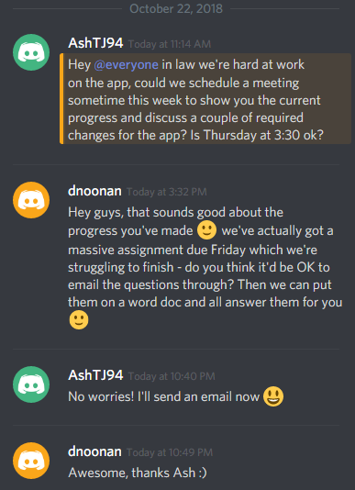

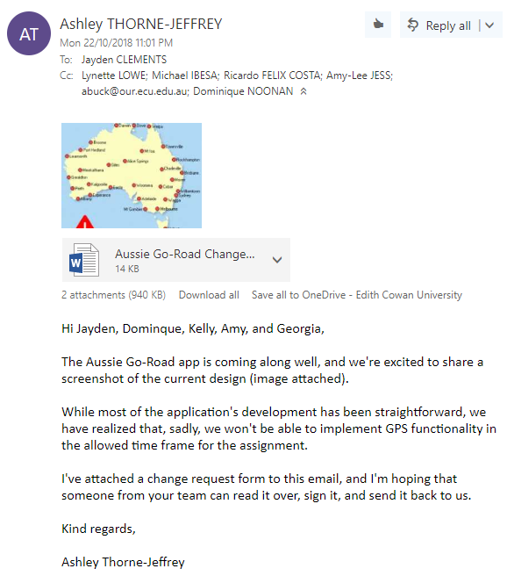

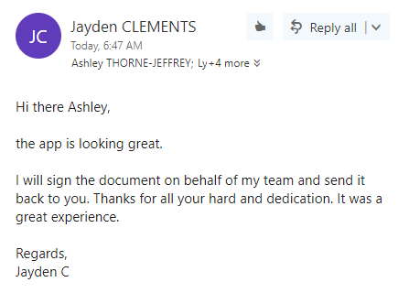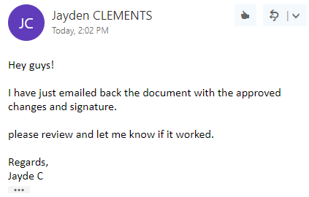

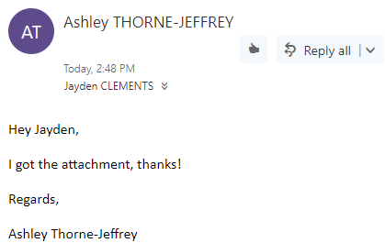

Client Communication 2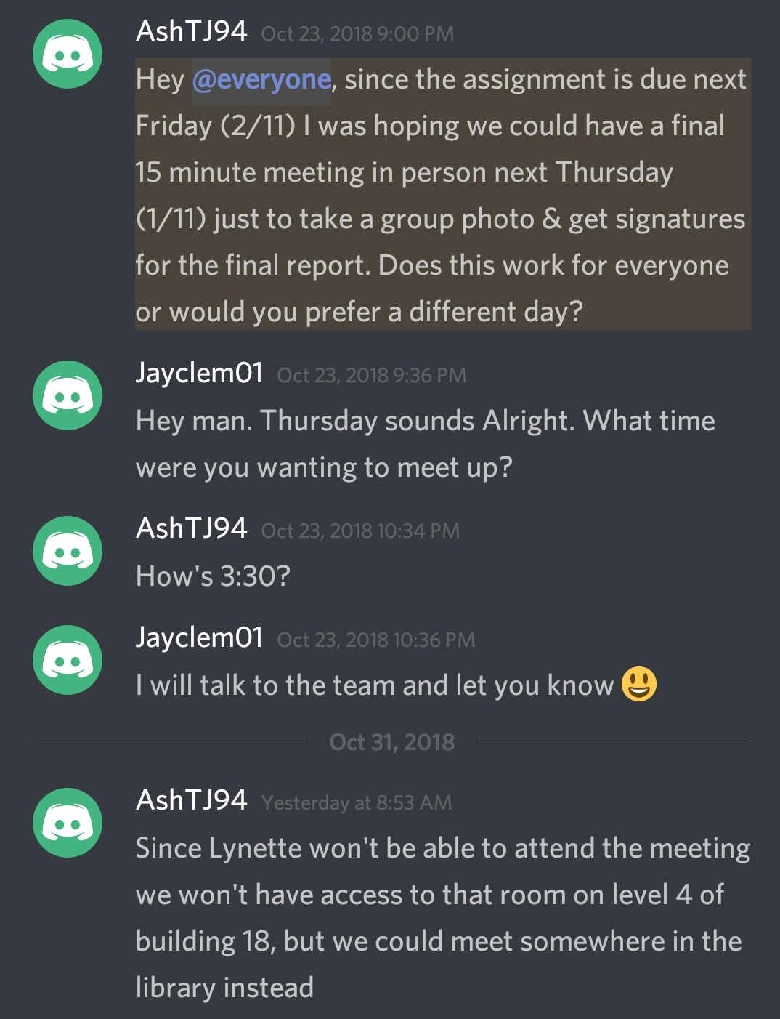

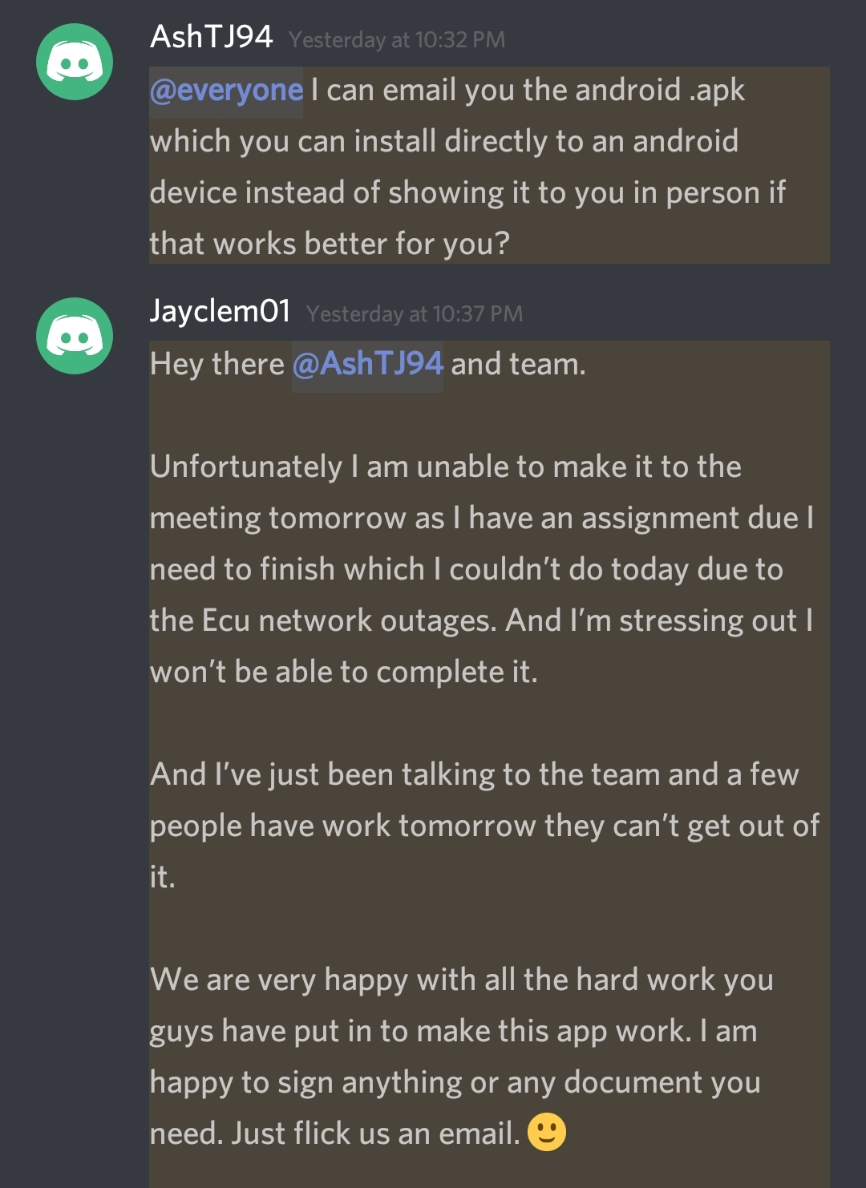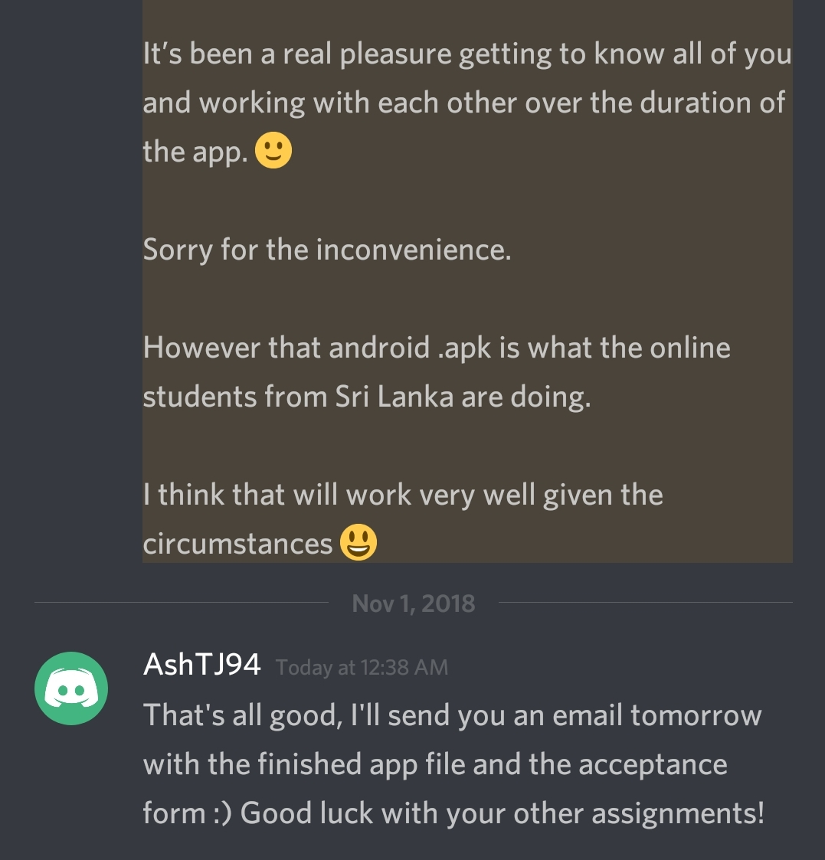

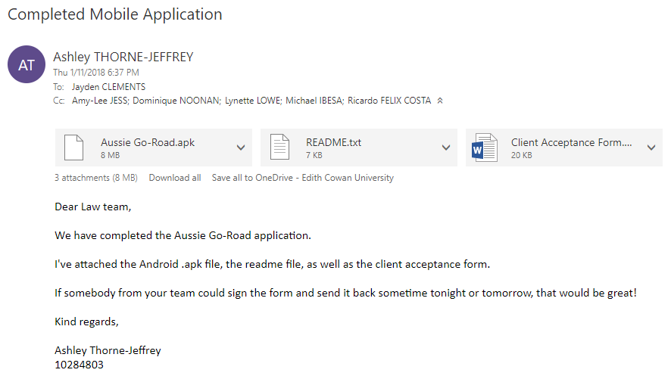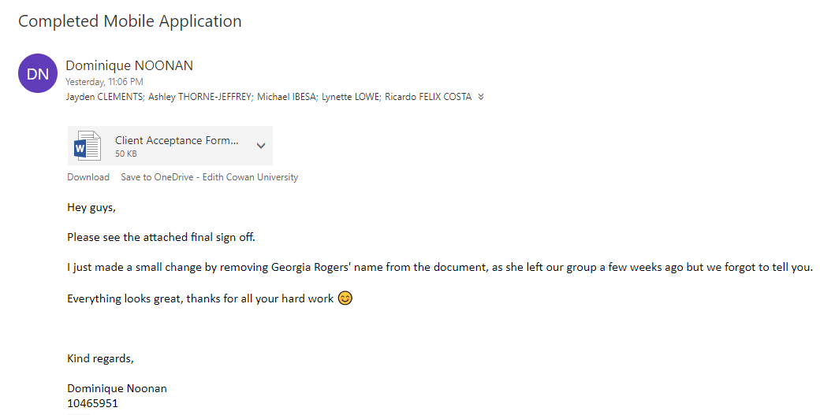

# Evidence of Appropriate Configuration Management

We used GitHub as our configuration management tool. View our application’s development progress on GitHub here: <https://github.com/KageBunshin21/Aussie_Go-Road>

# Evidence of Pair-Programming

## Photographic Evidence

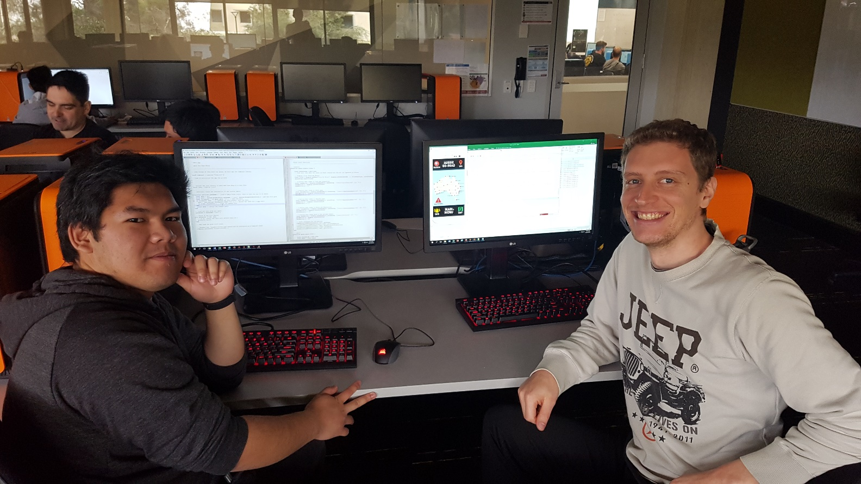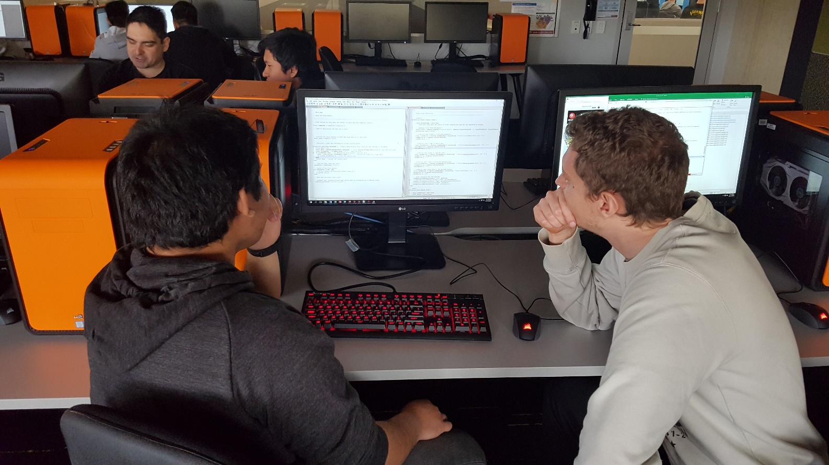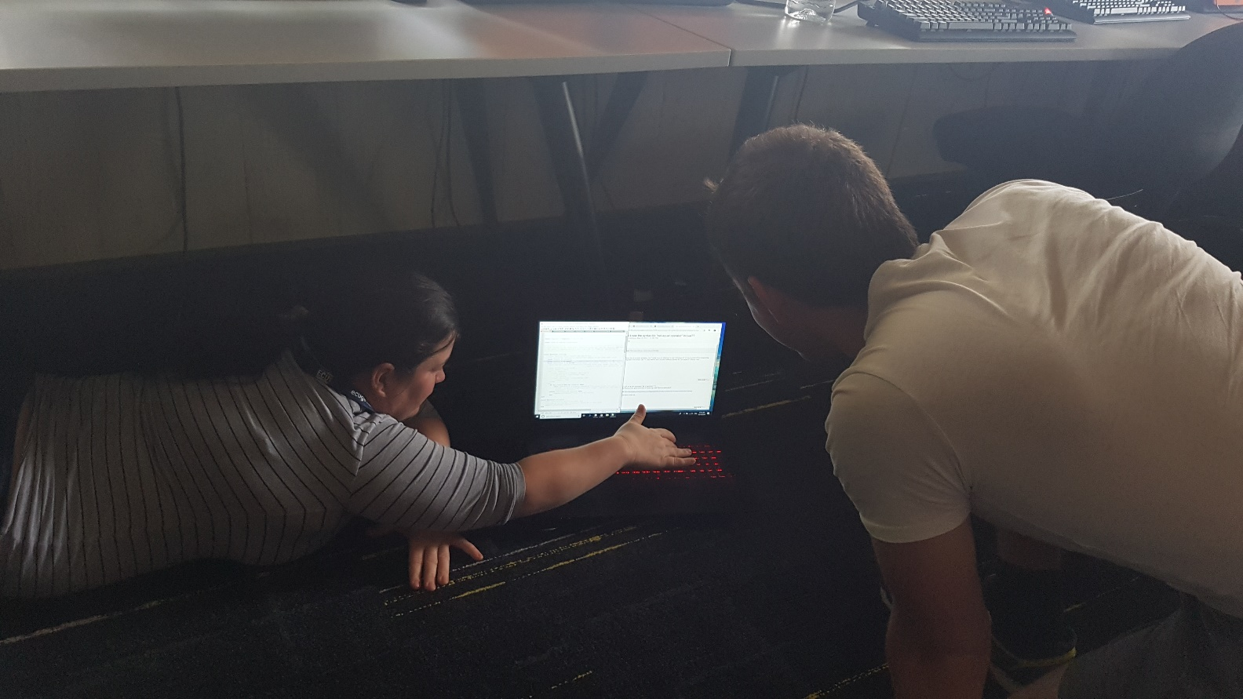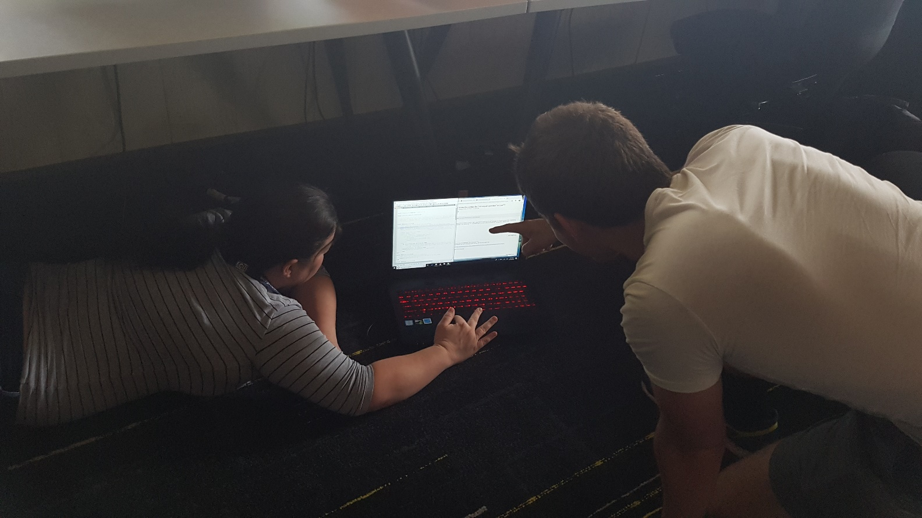

## Textual Evidence

Each of our Lua files contains the names of the pair who worked on them. Please view the top lines of each Lua file to verify that we did in fact engage in pair-programming.

# Scope Change

## Proposed Scope Change

Shortly after beginning development of the Aussie Go-Road application, the project team realized that implementing GPS functionality would be too great a task to complete by the project deadline. Therefore, we decided to submit a change request form to the client to remove the GPS components from the functional & non-functional requirements of the app.

Two functional requirements would be entirely removed:

* The traveler must be able to see their current latitude and longitude.
* The emergency services personnel must be able to locate a traveler via their GPS location.

And three functional requirements would have all mention of “current location” removed:

* The traveller must be provided with interesting facts and points of interest related to their current location & target destination.
* The traveller must have access to the rules and regulations of their current location & target destination.
* The traveller must have access to the Aboriginal Land permissions of their current location & target destination.

Once the project team decided on which functional requirements to amend, we drafted a change request form and received the client’s sign off.

## Change Request & Approval

|  |  |  |  |
| --- | --- | --- | --- |
| **1.) CHANGE REQUEST** | | | |
| **Change Request #** | 1 | | |
| **Project** | Aussie Go-Road | | |
| **Submitter Name** | Ashley Thorne-Jeffrey | | |
| **Brief Description of Request** | Remove GPS functionality & all mention of “current location” from the list of functional requirements for the Aussie Go-Road application. | | |
| **Priority** | High | | |
| **Reason for Change** | The project team realized that we would not be able to implement GPS functionality before the project’s deadline. | | |
| **Assumptions and Notes** | If this change request is approved, the project will be completed by the project’s deadline (02/11/2018) | | |
| **Approval Signature** |  | **Date Signed** | 23/10/2018 |

|  |  |  |  |
| --- | --- | --- | --- |
| **2.) CLIENT DECISION** | | | |
| **Decision** | Approved | | |
| **Client Name** | Jayden Clements | | |
| **Client Signature** |  | **Date Signed** | 23/10/2018 |

## Updated List of Functional & Non-Functional Requirements

As per the approved change request form, this is the new list of functional & non-functional requirements:

Functional Requirements:

* The traveller must be able to search for a location via a search bar.
* The traveller must be able to plan their route.
* The traveller must be provided with the relevant contact information to report incidents.
* The traveller must be provided with general safety warnings/cautions.
* The traveller must be provided with general tips, tricks, and suggestions for traveling in Australia.
* The traveller must be able to send an SOS (call emergency services).
* The traveller must be provided with interesting facts and quick tips for all locations in the app.
* The traveller must be provided with the laws and regulations for each state of Australia.
* The traveller must be provided with a link to view the Aboriginal Land permissions.

Non-functional Requirements:

* The application must be programmed in Lua.
* The application must be easy to navigate.
* The application must be up-to-date.

# Black Box Testing

The black box testing is based on the functional and non-functional requirements. The test is conducted by checking every functionality of the application and to see if there are any errors that may occur after it is installed into an android phone. Below are the screenshots that correspond with each functionality.

NOTE: To understand the flow and navigation of the app, please refer to the manual (README.txt).

Welcome Screen Main Menu Screen

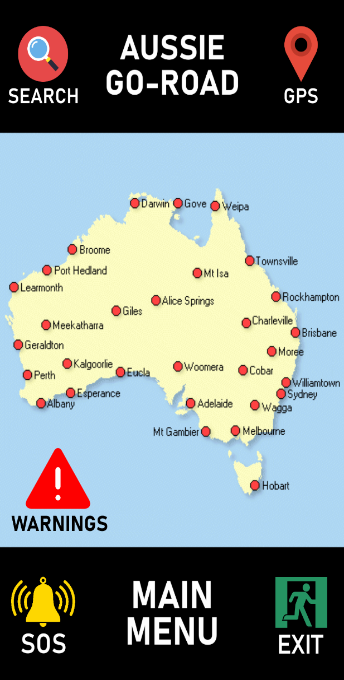 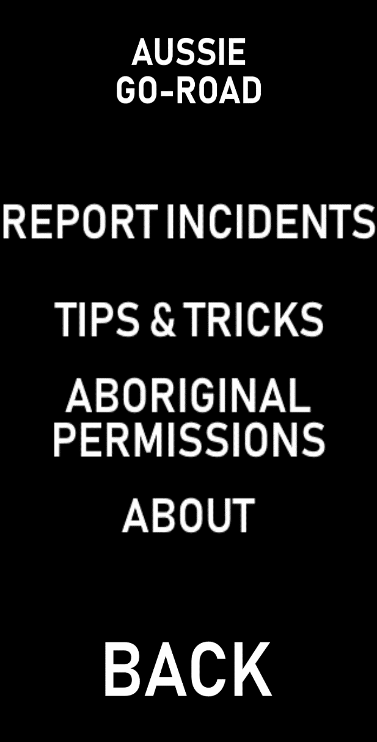

* Functional Requirement: The traveller must be able to search for a location via a search bar.

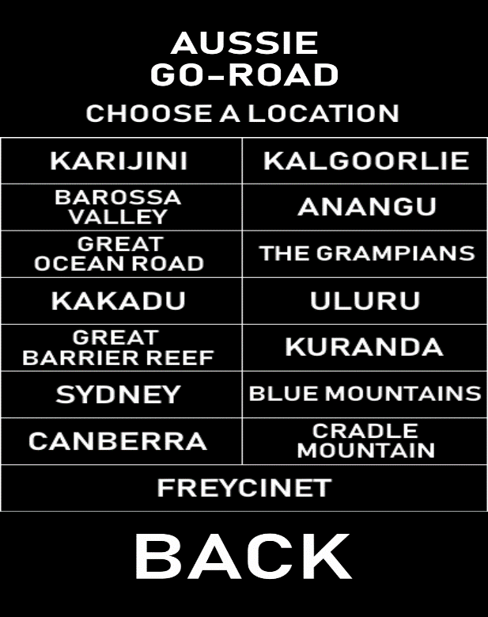

* Search page

This section works as it is intended, but the search bar was omitted due to a lack of time. After tapping on the location, it will move to another page that shows relevant information about it.

* Pass
* Functional Requirement: The traveller must be provided with the relevant contact information to report incidents.

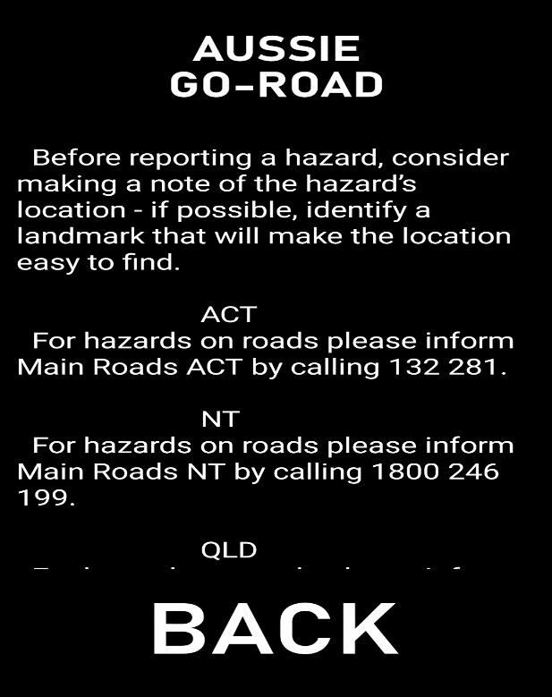

* Report Incidents page

We have provided the information on which number to contact if there are any incidents to report.

* Pass
* Functional Requirement: The traveller must be provided with general safety warnings/cautions.

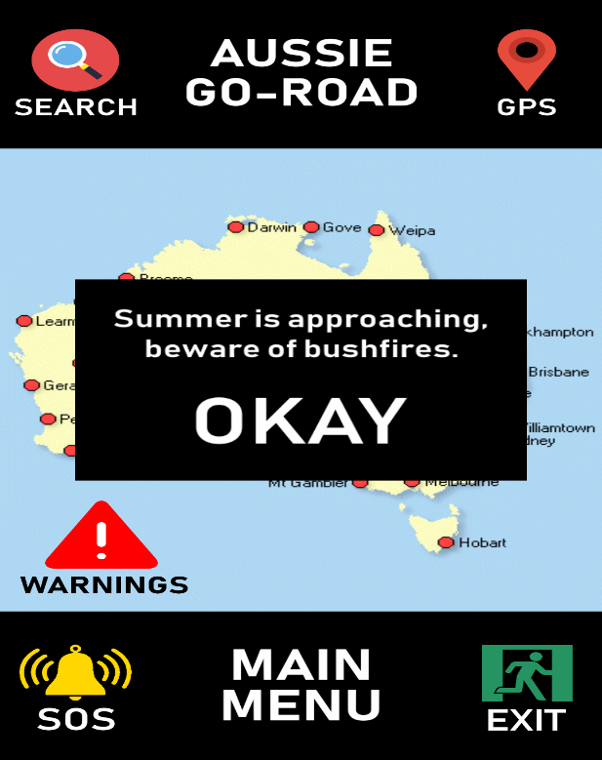

* Warning window

Provides a safety warnings/cautions when tapping on the warnings button.

* Pass
* Functional Requirement: The traveller must be able to plan their route.

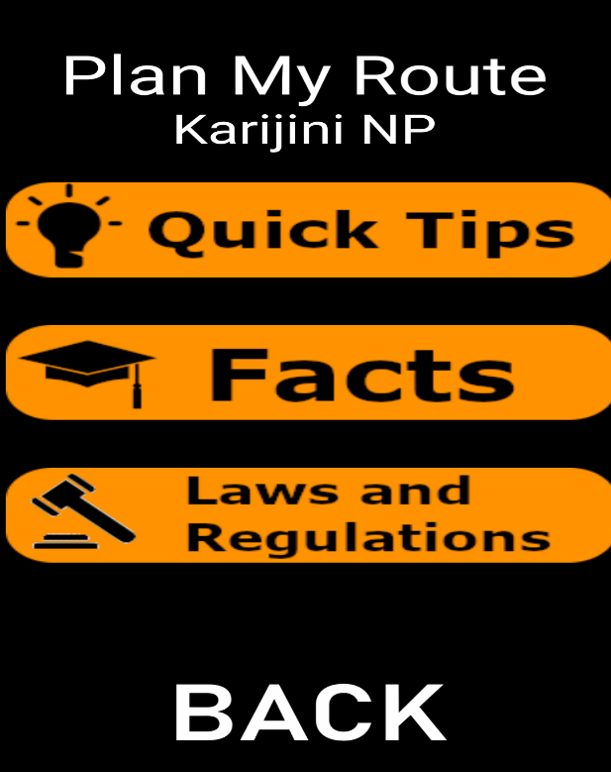

* Plan My Route page

The selected location from the search page is carried over to this page, that is why we were able to show the name of the location as a subheading. The buttons in this page will show the information about the selected location.

* Pass
* Functional Requirement: The traveller must be provided with general tips, tricks, and suggestions for traveling in Australia.



* Tips and Tricks page

This page contains 3 buttons that will redirect the user to the pages shown below. It provides a lot of information and guide on how to travel around Australia. For example, be mindful of creatures that can cause harm.

* Pass

 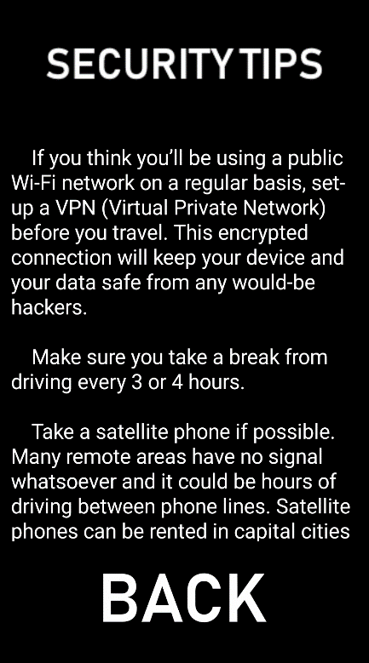 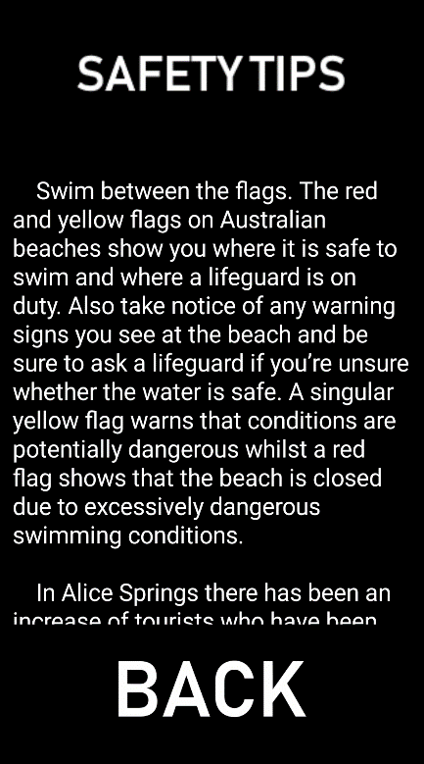

* Functional Requirement: The traveller must be able to send an SOS (call emergency services).

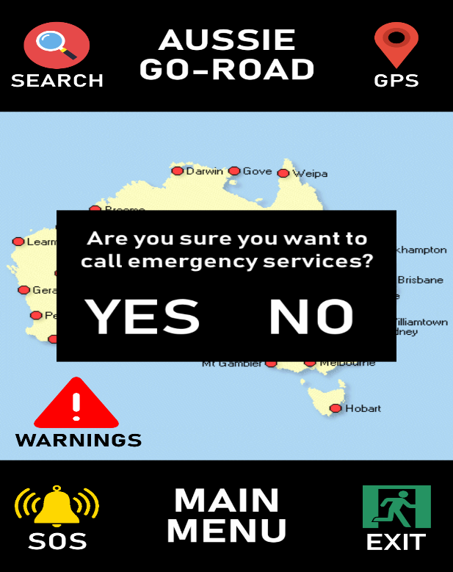

* SOS button

The SOS button located on the bottom left of the welcome screen will attempt to dial 000 after the user clicks yes on the prompted message.

* Pass
* Functional Requirement: The traveller must be provided with interesting facts and quick tips for all locations in the app.

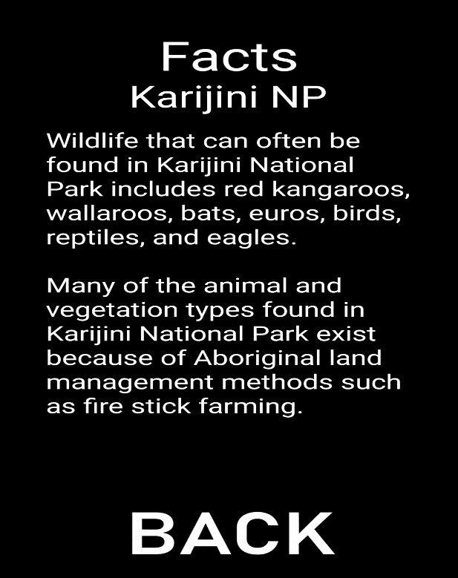

* Facts page

This page has the information on some of the facts regarding of the selected location.

* Pass

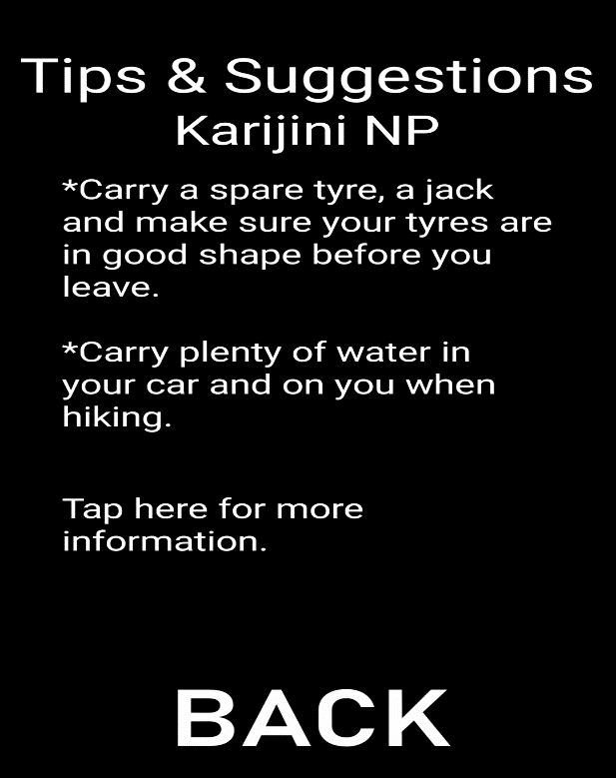

* Tips and Suggestions page

This page shows the tips and suggestions for the selected location. There is also a link of a website embedded on the text “Tap here for more information.” Which allows the user to know more information about the place.

* Pass
* Functional Requirement: The traveller must be provided with the laws and regulations for each state of Australia.

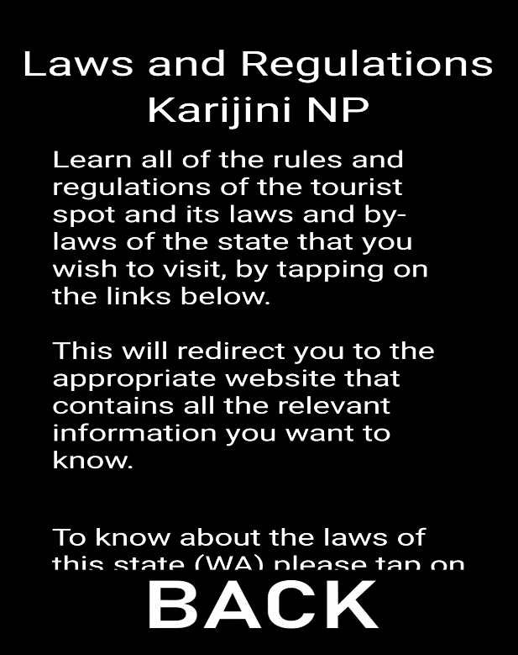

* Laws and Regulations page

This page is a combination of Laws/By-laws with Rules and Regulations since they all relate to one another. It contains a link that will redirect the user to the laws/by-laws of the state and rules and regulation of the selected location.

* Pass
* Functional Requirement: The traveller must be provided with a link to view the Aboriginal Land permissions.



* Aboriginal Permissions page

This page explains what aboriginal permissions are about and has a link that will redirect the user to a website with the aboriginal permissions.

* Pass

# Client Acceptance

|  |  |  |  |
| --- | --- | --- | --- |
| **CLIENT ACCEPTANCE FORM** | | | |
| **Project Name** | Aussie Go-Road | | |
| **Project Team** | Ashley Thorne-Jeffrey, Lynette Lowe, Michael Ibesa, Ricardo Costa | | |
| **Project Client** | Amy Jess, Dominique Noonan, Georgia Rogers, Jayden Clements, Kelly Buck | | |
| **Project Description** | Aussie Go-Road is an app that allows users to plan their journey across Australia. It offers helpful information about popular destinations, as well as provides laws, bylaws, rules, and regulations. It also allows users to search for popular travel destinations and displays relevant warning messages. | | |
| **Deliverables** | * A fully functional Android application named “Aussie Go-Road” * A readme file that explains everything about the Android application | | |
| **Prepared By** | Ashley Thorne-Jeffrey | **Date Signed** | 1/11/2018 |
| **Approved By** | Dominique Noonan | **Date Signed** | 1/11/2018 |

# Readme

You will find the readme file inside the submission .zip folder as well as inside the GitHub repository here: <https://github.com/KageBunshin21/Aussie_Go-Road>

# Group Self-Reflection

What went well:

* Using GitHub for configuration management made version control easy. When one pair made any changes to the code, they could easily commit them to the repository, and the other pair would be able to grab the latest version of the code and continue working.
* By communicating with the client regularly, we were able to manage expectations and receive continuous feedback on how the application was developing.

What did not work (and what we did about it):

* Early in the development process we realized that we would not be able to implement GPS functionality and get the application finished by the project deadline. We drafted a change request form and told the client that we wouldn’t be able to implement GPS. They signed the change request form, giving us official confirmation that it was acceptable to deliver a finished application without GPS functionality.
* The pair programming aspect of the assignment meant that to work on the assignment, we needed to meet up in person. This was difficult since different team members had different schedules, but we managed to meet up frequently enough to get the project finished before the deadline.

What we would do differently next time:

* Start development earlier, so when we discover any major issues (like not being able to implement GPS) we could correct our course earlier.
* Have more client meetings before & during development, so we could be absolutely 100% certain that we were developing the application that the client wanted.
* Know our own limitations and tell the client exactly what is and isn’t possible to achieve before the project begins.

# References

123rf. (2018). Bell Vector Icon Royalty Free Cliparts, Vectors, And Stock Illustration. Retrieved from <https://www.123rf.com/photo_62143617_stock-vector-bell-vector-icon.html>

Australian Atmospheric Sounding Information. (2002). About this website. Retrieved from <http://slash.dotat.org/atmos/info.html>

Clipart Max. (2018). Safety Running Man Symbol – Emergency Exit Sign Vector. Retrieved from <https://www.clipartmax.com/middle/m2i8K9H7N4i8m2d3_safety-running-man-symbol-emergency-exit-sign-vector/>

Free Icon Shop. (2018). Search Icon Flat – Icon Shop – Download free icons for commercial use. Retrieved from <https://freeiconshop.com/icon/search-icon-flat/>

Icon Finder. (2018). Warning Icon. Retrieved from <https://www.iconfinder.com/icons/183416/warning_icon>

My Icon Finder. (2018). Pin Icon. Retrieved from <http://www.myiconfinder.com/icon/pin-compas-gps-location-map-marker-navigate-position/8807>